**PROJECT 3: Charlotte Crime Rate**

Team Gryffindor: Bri Beyer, Angelique Nixon,

Joshua Moe, JaQuana Pharr, and Nicoletta Sheppard

TOPIC: We will be analyzing the crime rate in Charlotte, NC to compare the different crimes, and create awareness in our community.

DATASET: <https://data.charlottenc.gov/datasets/d22200cd879248fcb2258e6840bd6726_0/explore?location=35.261109%2C-80.809400%2C9.97>

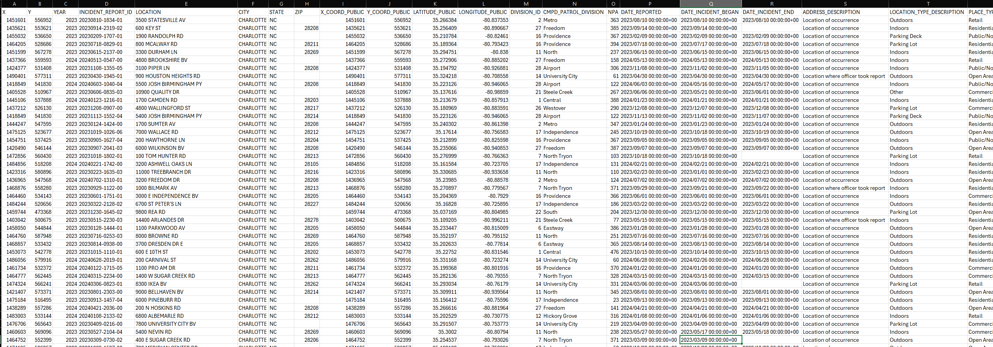

VISUAL INSPIRATIONS:

GitHub Repository: <https://github.com/42ocin/Project3_gryffindorTeam>